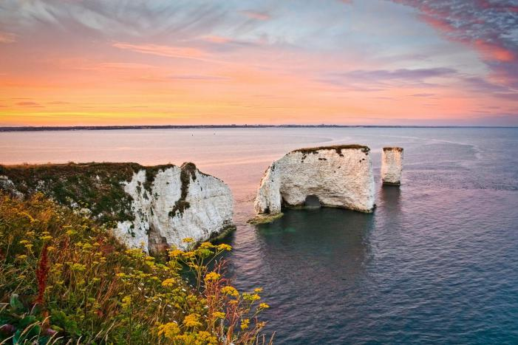

……………...………………………………………………………………………………………………………………………………………………………………………………………………………………………………………………………………………………

Question 4: Explain the formation of the landform shown in the picture **(6 marks)**

Your Score

Revision Focus Area:



**Check 20**

Paper 1, Section C: Physical Landscapes in the UK

Coastal Landforms

Answer 20 marks in 20 minutes

Question 1: A landform is a feature of the landscape that has been formed by three processes. Name these three processes **(3 marks)**

1…………...……………………………………………………………………………………………………………………2…………………………………………………………………………………………………………………………………3…………………………………………………………………………………………………………………………………

……………...…………………………………………………………………………………………………………………………………………………………………………………………………………………………………………………………………………………………………………………………………………………………………………………………………………………………………………………………………………………………………………………………………………………………………………………………………………………………………………………………………………

Question 2: Using the diagram, explain the formation of headlands and bays  **(4 marks)**

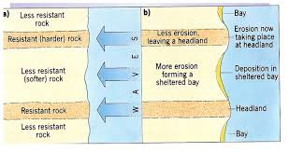

……………...…………………………………………………………………………………………………………………………………………………………

Question 5: Explain how the processes of transport and deposition lead to the formation of spits **(6 marks)**

……………...………………………………………………………………………………………………………………………………………………………………………………………………………………………………………………………………………………………………………………………………………………………………………………………………………………………………………………………………………………………………………………………………………………………………………………………………………………………………………………………………………………………………………………………………………………………………………………………………………………………………………………………………………………………………………………………………………………………………………………………………………………………………………………………………………………………..

……………...……………………………………………………………………………………………………………………

Question 3: Identify the wave type associated with formation of beaches  **(1 mark)**

……………...……………………………………………………………………………………………………………………………………………………………………………………………………………………………………………………………………………………………………………………………………………………………………………………………………………………………………………………………………………………………………………………………………………………………………………………………………………………………………………………………………….