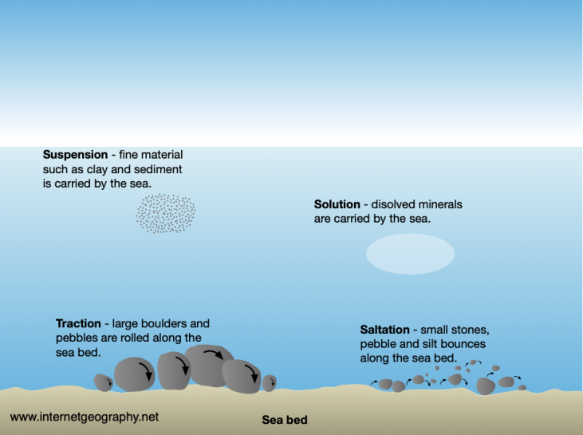

Question 4: Add the missing labels for the four processes of coastal transport to the diagram **(4 marks)**

Your Score

Revision Focus Area:

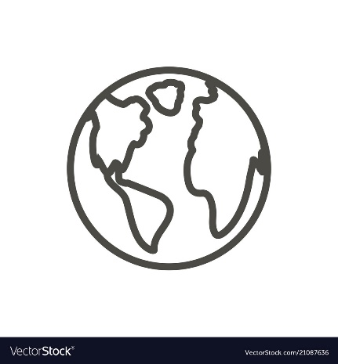

**Check 20**

Paper 1, Section C: Physical Landscapes in the UK

Coastal Processes

Answer 20 marks in 20 minutes

Question 1: Compare the characteristics of constructive and destructive waves **(4 marks)**

……………...…………………………………………………………………………………………………………………………………………………………………………………………………………………………………………………………………………………………………………………………………………………………………………………………………………………………………………………………………………………………………………………………………………………………………………………………………………………………………………………………………………

Question 5: Describe the process of longshore drift with the use of a diagram **(4 marks)**

Question 2: Match the definitions **(4 marks)**

……………...………………………………………………………………………………………………………………………………………………………………………………………………………………………………………………………………………………………………………………………………………………………………………………………………………………………………………………………………………………………………………………………………………………………………………………………………………………………………………………………………………………………………………………………………………………………………………………………………………………

This is caused by chemical processes dissolving rocks and minerals

Mechanical weathering

……………...………………………………………………………………………………………………………………………………………………………………………………………………………………………………………………………………………………………………………………………………………………………………………………………………

Question 6: Describe the process of wave refraction **(2 marks)**

……………...………………………………………………………………………………………………………………………………………………………………………………………………………………………………………………………………………………………………………………………………………………………………………………………………

Question 3: Define biological weathering and give an example of this. **(2 marks)**

The physical break up of rocks

Removal of material by a moving force

Downward movement of material due to gravity

Erosion

Chemical weathering

Mass movement