

Question 6: Explain the physical processes that take place at destructive plate margins **(4 marks)**

Your Score

Revision Focus Area:

Paper 1, Section A: Natural Hazards

Plate

Margins

Answer 20 marks in 20 minutes

……………...………………………………………………………………………………………………………………………………………………………………………………………………………………………………………………………………………………………………………………………………………………………………………………………………………………………………………………………………………………………………………………………………………………………………………………………………………………………………………………………………………..

**Check 20**

Question 3: Explain why the majority of earthquakes and volcanoes happen at plate margins **(4 marks)**

Question 1: Define natural hazard **(1 mark)**

……………...……………………………………………………………………………………………………………………

Question 2: What is a plate margin? **(1 mark)**

……………...……………………………………………………………………………………………………………………

_________________ margin: two plates move past each other, with friction causing earthquakes. No volcanoes are located on these margins.

_________________ margin: two plates are moving apart. Magma forces its way to the surface.

Question 7: Describe the pattern of earthquakes and volcanoes **(4 marks)**

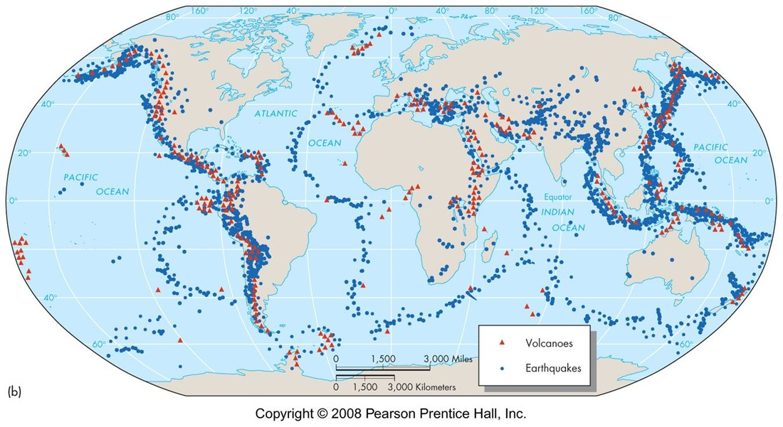

……………...………………………………………………………………………………………………………………………………………………………………………………………………………………………………………………………………………………………………………………………………………………………………………………………………………………………………………………………………………………………………………………………………………………………………………………………………………………………………………………………………………..

……………...………………………………………………………………………………………………………………………………………………………………………………………………………………………………………………………………………………………………………………………………………………………………………………………………………………………………………………………………………………………………………………………………………………………………………………………………………………………………………………………………………………………………………………………………………………………………………………………………………………………………………………………………………………………………………………………………………………………………………………………………………………………………………………………………………………………………………………………………………………………………………………………………………………………………………………………………………………………………………………………………………………………………………………………………………………………………………………………………………………………………………..

Question 4: Identify the type of plate margin from the description **(3 marks)**

……………...………………………………………………………………………………………………………………………………………………………………………………………………………………………………………………………………………………………………………………………………………………………………………………………………

Question 8: State what a hot spot is and give an example **(2 marks)**

Question 5: Identify one cause of an earthquake that does not occur at a margin **(1 mark)**

……………...……………………………………………………………………………………………………………………

_________________ margin: two plates move towards each other. Oceanic crust is subducted below continental crust