

Question 3: ‘The rainforest is more valuable when left intact then when destroyed. ‘To what extent do you agree? **(9 marks)**

Your Score

Revision Focus Area:

Paper 1, Section B: The Living World

Rainforest Management

Answer 20 marks in 20 minutes

……………...……………………………………………………………………………………………………………………………………………………………………………………………………………………………………………………………………………………………………………………………………………………………………………………………………………………………………………………………………………………………………………………………………………………………………………………………………………………………………………………………………………………………………………………………………………………………………………………………………………………………………………………………………………………………………………………………………………………………………………………………………………………………………………………………………………………………………………………………………………………………………………………………………………………………………………………………………………………………………………………………………………………………………………………………………………………………………………………………………………………………………….

**Check 20**

Question 1: Describe the trend in deforestation shown in the graph **(3 marks)**

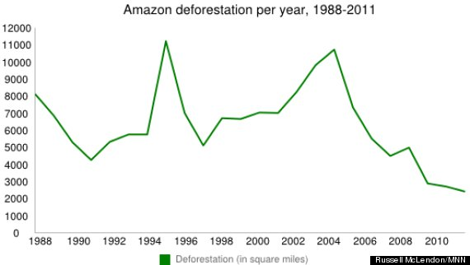

Question 4: Explain two benefits of international cooperation in sustainably managing rainforests **(4 marks)**

…………………………………………………………………………………………………………………………………………………………………………………………………………………………………………………………………………………………………………………………………………………………………………………………………………………………………………………………………………………………………………………………………………………………………………………………………………………………………………………………………………………………

……………………………………………………………………………………………………………………………………………………………………………………………………………………………………………………………………………………………………………………………………………………………………………………………………………………………………………………………………………………………………………………………………………………

Question 2: Outline one reason that rainforests should be protected **(2 marks)**

1…………...……………………………………………………………………………………………………………………2…………………………………………………………………………………………………………………………………

Question 5: Identify two other ways of managing rainforests **(2 marks)**

……………...……………………………………………………………………………………………………………………………………………………………………………………………………………………………………………………………………………………………………………………………………………………………………………………………..