Question 5: Figure 1 shows a river landform. Explain how this landform is formed by a river **(6 marks)**

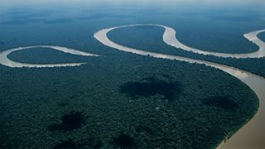

……………...……………………………………………………………………………………………………………………………………………………………………………………………………………………………………………………………….

Levee

Interlocking Spurs

Estuary

Meander

Waterfalls

Floodplain

Question 3: Match the landform to the course of the river it is located in **(6 marks)**

Question 2: Define vertical erosion **(1 mark)**

……………...………………………………………………………………………………………………………………….

……………...………………………………………………………………………………………………………………….

**Check 20**

Paper 1, Section C: Physical Landscapes in the UK

River Landforms

Answer 20 marks in 20 minutes

Question 1: Define lateral erosion **(1 mark)**

Your Score

Revision Focus Area:

……………...…………………………………………………………………………………………………………………………………………………………………………………………………………………………………………………………………………………………………………………………………………………………………………………………………………………………………………………………………………………………………………………………………………………………………………………………………………………………………………………………………………………………………………………………………………………………………………………………………………………………………………………………………………………………………………………………………………………..

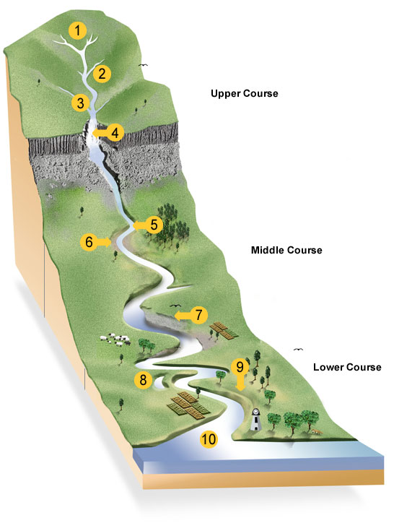

……………...…………………………………………………………………………………………………………………………………………………………………………………………………………………………………………………………………………………………………………………………………………………………………………………………………………………………………………………………………………………………………………………………………………………………………………………………………………………………………………………………………………………………………………………………………………………………………………………………………………………………………………………………………………………………………………………………………………………..

……………...……………………………………………………………………………………………………………………

……………………………………………………………………………………………………………………………………

Question 6: Explain why a waterfall is only a temporary feature on a river’s course **(4 marks)**

Question 4: Which types of erosion are most important in the formation of a waterfall? **(2 marks)**