

Question 4: Describe the primary and secondary effects of a tropical storm. Use a named example to support your answer. **(9 marks)**

Your Score

Revision Focus Area:

Paper 1, Section A: Natural Hazards

Circulation and Tropical Storms

Answer 20 marks in 20 minutes

……………...…………………………………………………………………………………………………………………………………………………………………………………………………………………………………………………………………………………………………………………………………………………………………………………………………………………………………………………………………………………………………………………………………………………………………………………………………………………………………………………………………………………………………………………………………………………………………………………………………………………………………………………………………………………………………………………………………………………………………………………………………………………………………………………………………………………………………………………………………………………………………………………………………………………………………………………………………………………………………………………………………………………………………………………………………………………………………………………………………………………………………………………………………………………………………………………………………………………………………………………………………………………………………………………………………………………………………………………..

**Check 20**

Question 1: Label the cells of the global atmospheric circulation model **(2 marks)**

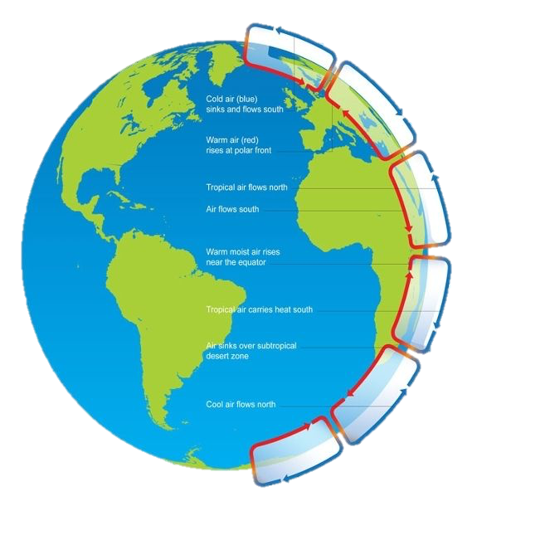

Ferrell Cell

Polar Cell

Hadley Cell

Question 2: Describe the conditions needed for a tropical storm to form **(3 marks)**

Question 5: Explain how planning and preparation can help to reduce the effects of tropical storms **(3 marks)**

……………...……………………………………………………………………………………………………………………………………………………………………………………………………………………………………………………………………………………………………………………………………………………………………………………………………………………………………………………………………………………………………………………………………

……………...……………………………………………………………………………………………………………………………………………………………………………………………………………………………………………………………………………………………………………………………………………………………………………………………………………………………………………………………………………………………………………………………………………………………………………………………………………………………………………………………………………………………………………………………………………………………………………………………………………..

……………...……………………………………………………………………………………………………………………………………………………………………………………………………………………………………………………………………………………………………………………………………………………………………………………………………………………………………………………………………………………………………………………………………

Question 3: Describe how climate change may affect tropical storms **(3 marks)**